NAALAIYA THIRAN

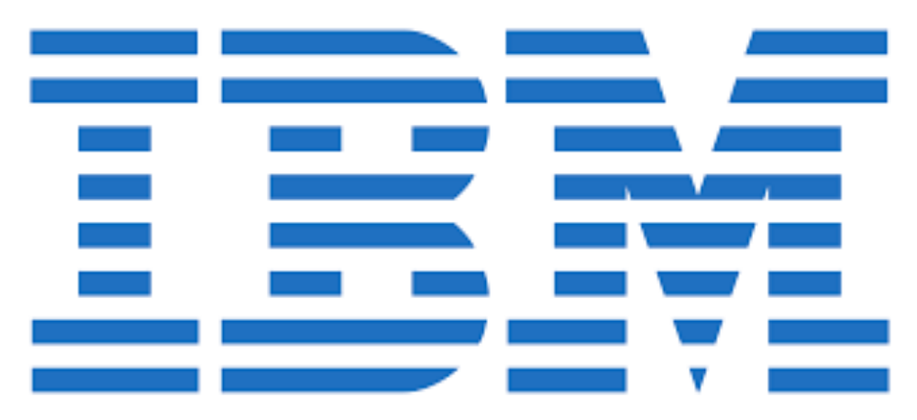

Survey on Smart Agriculture Using IOT

TEAM :
- ARUNA DEVI
- SURIYAKALA
- SINDHUMATHI
- STELLA

FACULTY MENTOR:
- JOTHILAKSHMI. P
Abstract:
People may use the internet of things to live and work smarter and achieve total control over their life. In order to increase crop productivity with fewer manual interventions, IoT is important in farming. IoT solutions are a type of system that uses various sensors (light, humidity, temperature, soil moisture, crop health etc) to monitor and automate different operations in an agricultural field. Farmers can monitor their fields from anywhere.They can also choose between manual and automated solutions for taking appropriate data-driven actions. When compared to traditional farming, smart farming is significantly more efficient. IoT allows automating operations and saving money on manpower. It also reduces waste and enhances service delivery by lowering the cost of manufacturing and delivering items and providing transparency into consumer transactions.
One of the important applications of Internet of Things is Smart agriculture. Smart agriculture reduces wastage of water, fertilizers and increases the crop yield. In the current agriculture system the specification such as temperature, moisture, humidity are detected manually which increases the labor cost, time and also monitoring cannot be done continuously. In this paper irrigation process is done automatically using different sensors which reduces the manual labor. Here a system is proposed to monitor crop-field using sensors for soil moisture, humidity and temperature.

Keywords:

*Agriculture Precision,
* Raspberry Pi,
* Temperature Sensor,
*Soil Moisture Sensor,
* Cloud,
*IOT,
*Sensors,
* LoRa.

Introduction:
Agriculture plays vital role to build country economy as it provides food for the whole population. In this way, it connects and communicates with all of the country's important businesses. If a country's agricultural foundation is quite vast, it is considered socially and economically wealthy. As a result, the agro-industry must implement IoT in order to feed this huge population. Major problems, such as rising food demand, climate change, extreme weather conditions, and environmental effects, must be overcome.
The Internet was once controlled solely by the user. Further Machine-to-machine (M2M) technology based on wired and wireless Internet was then created, together with smart communication technology [12]. The Raspberry Pi has a Broadcom BCM2835 system on a chip (SoC), which includes an ARM1176JZF-S 700MHz processor (The firmware includes a number of "Turbo" modes so that the user can try to attempt over clocking, up-to 1GHz, without affecting the warranty), Video Core IV GPU, [5] and 256 megabytes of RAM. IoT functions include data gathering and processing, planning and decision-making, and prescriptions and services [13].IoT in agriculture consists of a series of processes that collect data from crops, livestock, agricultural machinery, and farms; create a database based on the collected data; make an appropriate prescription based on expert analysis of key data; and deliver prescriptions to consumers via text message
Some of the most outstanding technologies that are combined with IoT to develop agricultural solutions are wireless sensor networks, cloud computing, middleware systems, and mobile applications [1,2]. LoRa is a widely used network radio in India because of its advantages such as long range, low power consumption, and its low-cost investment [3, 4].
In agriculture, IoT is used for a wide range of activities, and applications can be broadly divided into four categories as (a) management systems, (b) monitoring systems, (c) control systems, and (d) unmanned machinery.

Components of IOT:
The architecture of IoT was composed of three layers. The front end layer collects weather parameters generated by different agricultural operations. The intermediate layer works as a gateway layer, connecting the front end layer to the Internet. The back end layer collects all of the front end data [14].

I. Sensors/Devices
Devices and sensors are the components of the device connectivity layer. These smart sensors are continuously collecting data from the environment and transmit the information to the next layer.Some of the most common devices used in IOT are optical sensors to measure soil properties, photodiodes and photo detectors to determine soil, organic matter, and soil moisture, moisture sensors to measure the amount of water in the soil, and geo-positioning devices to determine latitude, length, and altitude It's important to keep in mind that geolocation devices are a crucial component of precision agriculture[10].

Common sensors are:
• Temperature sensors and thermostats
• Pressure sensors
• Humidity / Moisture level
• Light intensity detectors
• Soil nutrient sensors
• Proximity detection
• RFID tags

II. Connectivity
Data from sensors is transferred to a cloud infrastructure, but it requires a medium for transit. Sensors can be linked to the cloud using a variety of communication and transport mediums, including cellular networks, satellite networks, Wi-Fi, wide-area networks (WAN), low power wide area network LoRAWAN, ZigBee, Bluetooth, Z-wave, and others.
The advancement of wireless communication technology results in lower costs, lower power consumption, and small-scale multifunctional sensors that allow for short-range communication.[9]

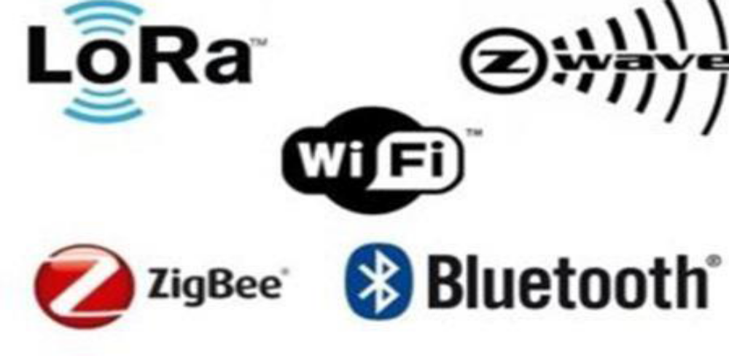

III. Gateway
The IoT Gateway handles bidirectional data flow between various networks and protocols. Another role of a gateway is to translate various network protocols and ensure the compatibility of linked devices and sensors. Gateways can be set to do local pre-processing of data obtained through various sensors before sending it to the next step. It protects the system from harmful threats and unauthorized access by acting as an intermediate layer between devices and the cloud.

IV. Cloud
The Internet of Things generates vast amounts of data from devices, apps, and users, which must be managed efficiently. IoT cloud provides capabilities for collecting, processing, managing, and storing vast amounts of data in real time. These data may be easily accessed remotely by industries and services, allowing them to make vital choices as needed.

V. Data Processing and analytics
Once the data has been gathered then sent to the cloud, the software processes it. This might range from something as easy as ensuring that the temperature reading on equipment like thermometer is within an acceptable range. It may also be highly complicated, such as employing computer vision on video to detect pests. Each alternative has its own set of characteristics and exchange between energy consumed, range, and bandwidth. As a result, selecting the optimum connectivity choice in the IOT system is essential. The process of converting analog output from various smart devices and sensors into usable insights that can be analyzed and used for deep analysis is known as analytics. Smart analytics solutions are necessary for IoT systems in order to manage and enhance system.

VI. User Interface
Next, the information made available to the end-user in some way. This can achieve by triggering alarms on their phones or notifying through texts or emails. User interfaces are the visible, physical components of an IoT system that users may access. Designers will need to provide a well-designed user interface that requires the least amount of work from users

Raspberry Pi
The Raspberry Pi is a credit card sized single-board computer developed in the UK by the Raspberry Pi Foundation with the intention of stimulating the teaching of basic computer science in schools. The Raspberry Pi has a Broadcom BCM2835 system on a chip (SoC), which includes an ARM1176JZF-S 700MHz processor (The firmware includes a number of "Turbo" modes so that the user can try to attempt over clocking, up-to 1GHz, without affecting the warranty), Video Core IV GPU, [5] and 256 megabytes of RAM.

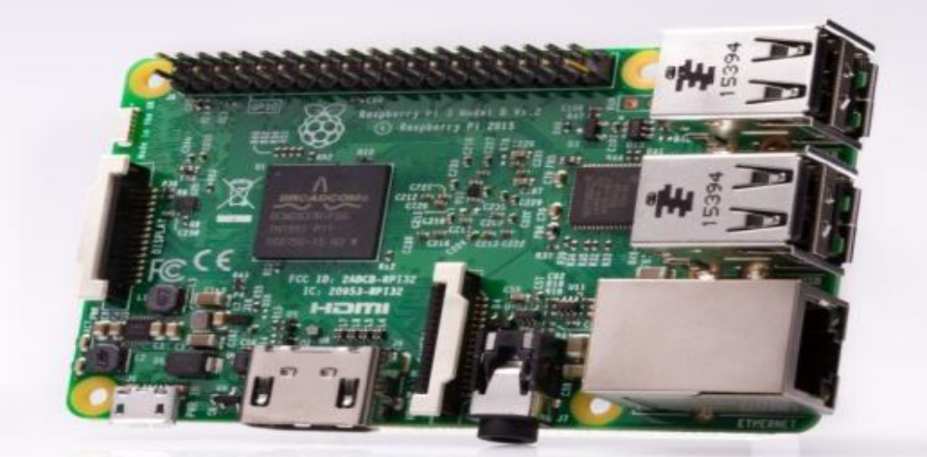

Arduino
The Arduino UNO is a widely used open-source microcontroller board based on the ATmega328P microcontroller and developed by Arduino.cc. The board is equipped with sets of digital and analog input/output (I/O) pins that may be interfaced to various expansion boards (shields) and other circuits.[1] The board features 14 Digital pins and 6 Analog pins.
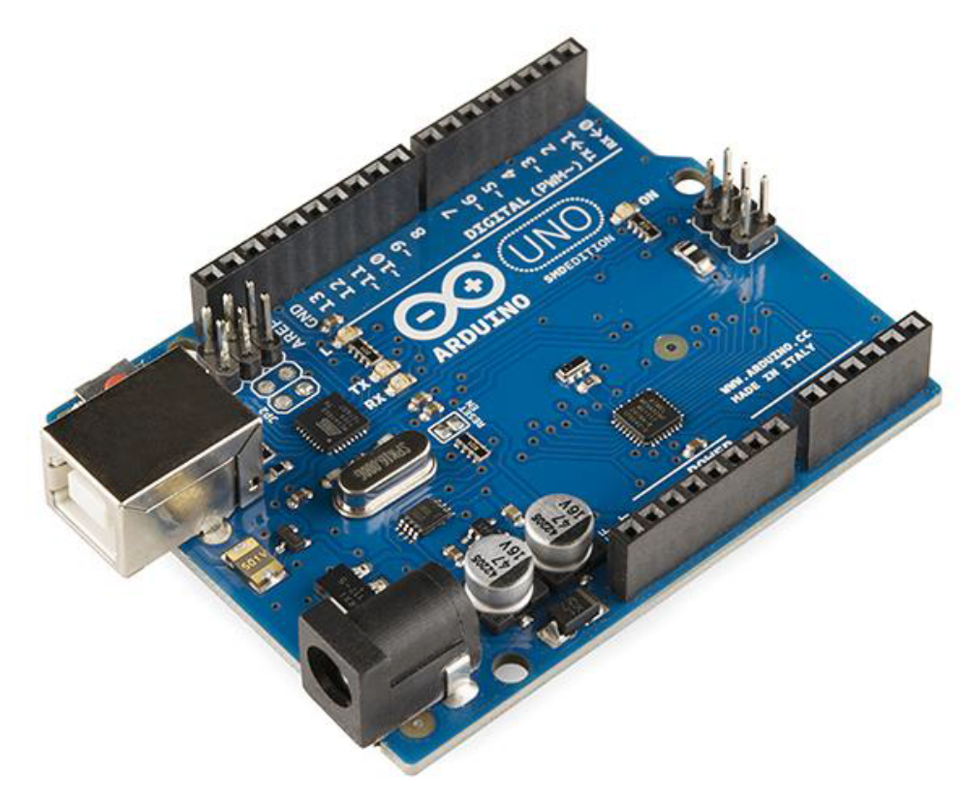

Soil Moisture Sensor
The Moisture sensor is used to measure the water content (moisture) of soil. When the soil is having water shortage, the module output is at high level else the output is at low level. This sensor reminds the user to water their plants and also monitors the moisture content of soil. It has been widely used in agriculture, land irrigation and botanical gardening.
S
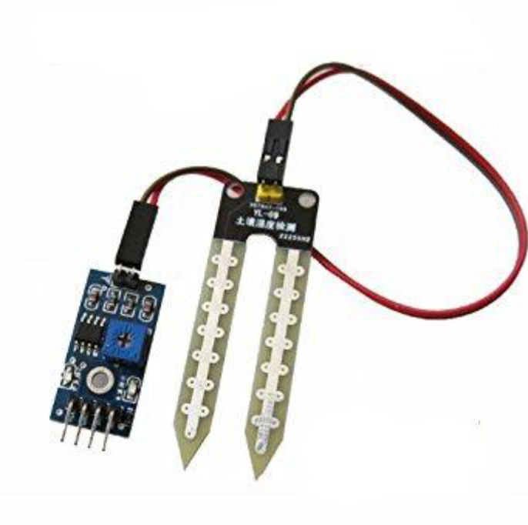

DHT11 Temperature & Humidity Sensor
This DHT11 Temperature & Humidity Sensor features a temperature & humidity sensor complex with a calibrated digital signal output. By using the exclusive digital-signal-acquisition technique and temperature & humidity sensing technology, it ensures high reliability and excellent long-term stability.

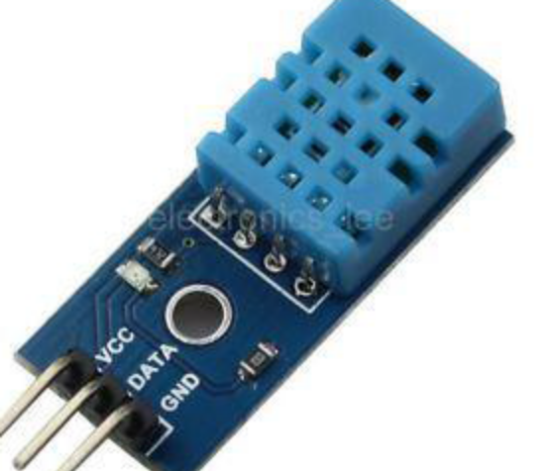

Applications of IoT in Agriculture:
The Internet of Things has made smart farming possible. Smart farming based on IoT refers to a system designed to monitor crop fields using sensors. These sensors monitor every crop- related nutrient. Smart farming based on IoT not only modernizes traditional farming methods, but also targets other agriculture methods such as organic farming, family farming (complex or small spaces, specific cattle and/or cultures, preservation of specific or high- quality varieties, and so on), and enhances highly transparent farming. There are various applications of IOT in agriculture.

1. Precision Farming
Precision agriculture is defined as anything that improves the accuracy and control of the farming process when it comes to producing animals and cultivating crops. Precision farming is distinguished by manufacturers' utilization of high-speed internet, mobile devices, and dependable, low-cost satellites (for images and location).Precision farming is one of the most well-known IoT applications in the agriculture industry, and it is being used by a number of organizations across the world.

2. Agricultural Drones
Unmanned aerial vehicles (UAVs) driven by IoT have facilitated in the conversion of agriculture from traditional farming techniques to a new level of intelligence in precision agriculture.[11]
In the agriculture industry, drones are being utilized to improve a variety of farming operations. Drones are used in agriculture for crop health evaluation, crop monitoring, pesticide spraying, irrigation, planting, and field analysis. There are two types of drones: ground-based and aerial-based drones.
During their flight, these drones collect multispectral, thermal, and visual data.Drones provide several advantages, including crop health imaging, integrated GIS mapping, time savings, simplicity of usage, and increased agricultural yields. We can give the agriculture industry a high-tech makeover by combining drone technology with effective strategy and planning based on real-time data collecting.

3. Livestock Monitoring
Large farm owners use wireless IoT apps to monitor the location, health, and well- being of their livestock. This knowledge enables them to identify sick animals and, from then on, segregate them from the herd, care for them, and prevent the sickness from spreading to other animals. It is also effective for reducing labour expenses since owners may locate their animals using IoT-based sensors.

4. Smart Greenhouses
Intelligent greenhouses are increasingly common in urban areas because they allow monitoring several parameters of nutrient solutions [5], as well as to improve the growth, yield, and quality of plants. Greenhouse farming is concerned with boosting the yields of vegetables, crops, and fruits, among many other things. IoT can be used to build a smart greenhouse. These smart greenhouses autonomously monitor and manage the environment even without manual intervention. In a smart greenhouse, several sensors are employed to evaluate environmental conditions and analyze their appropriateness for plants. By using IoT to interconnect the system to the cloud, a remote access is created. This reduces the need for continuous manual inspection. The cloud server manages data processing and executes a control action within the greenhouse.

5. Monitor Climate Conditions
Crop productivity is affected by the weather. Different crops require different climate conditions to grow, and even a rudimentary understanding of climate has a significant impact on crop quantity and quality. Farmers can use IoT technologies to get real-time weather updates. IoT technology-based systems with NPK sensors using light dependent resistors (LDRs) and light emitting diodes(LEDs) system provides guidance on the amount of fertilizer required for farmers at regular intervals by monitoring and analyzing nutrients present in the soil [15]

6. Remote sensing
Sensors installed around the farms, such as weather stations, are used in IoT-based remote sensing to collect data that is then sent to analytical tools for analysis. Farmers may monitor their field remotely.

7. Soil quality
The examination of soil quality assists in determining nutritional value and dehydrated farm parts, as well as soil draining capacity or acidity, which allows for the adjustment of irrigation water requirements and the selection of an efficient kind of cultivation.

8. Computer imaging
This type of photography mostly comprises using sensor cameras located across the farm to provide photos that are then processed digitally.These images are useful for getting accurate information regarding
➢ Quality control
Image processing coupled with machine learning compares photographs from the database to images of crops to determine size, shape, color, and growth, and adjusts the quality as an outcome.
➢ Sorting and grading
Sorting and grading product based on color, shape, and size can be simplified with computer imaging. Multiple agricultural machines are connected to each other by exchanging data through communication. Agricultural machinery companies that are global leaders have developed a tractor with auto guidance technology using GPS to improve working efficiency and reduce labor requirements [7].Tractor companies such as John Deere and Case IH are conducting ongoing research on autonomous tractors [8].

SYSTEM DESIGN

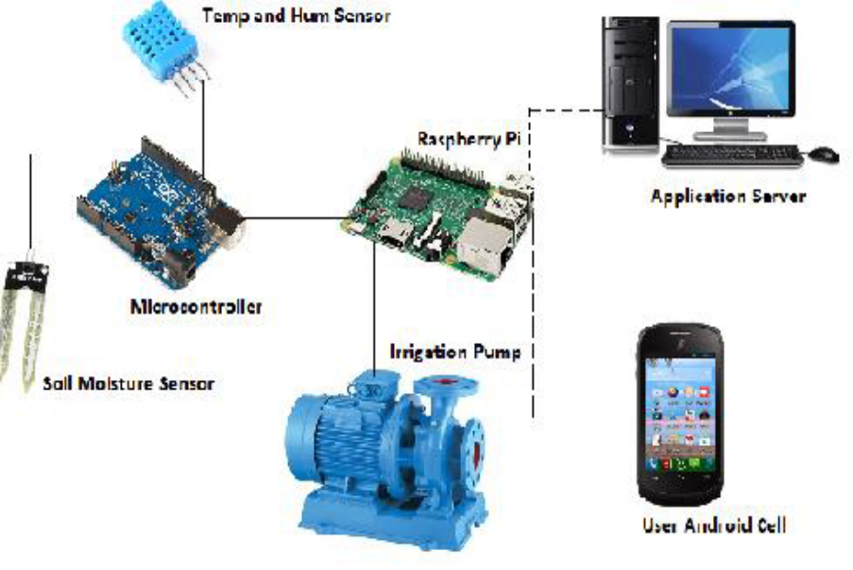

SYSTEM MODULE
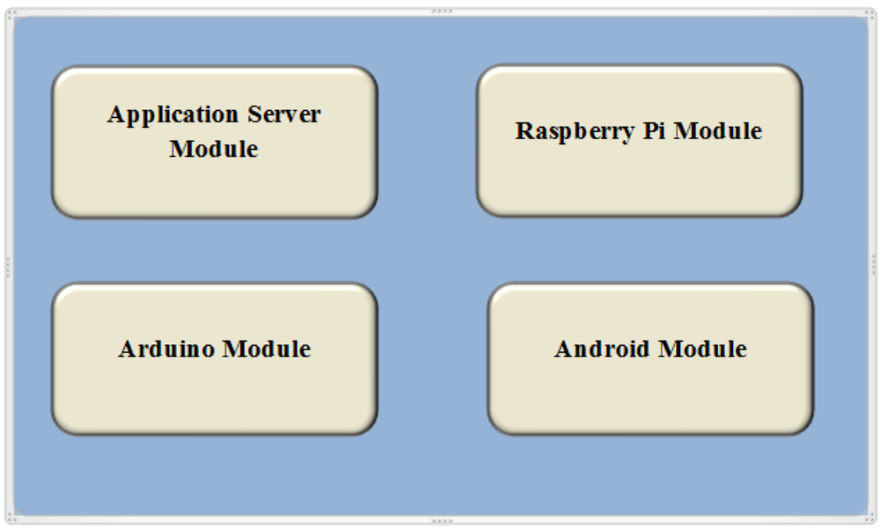

IMPLEMENTATION
This project can be implemented in a real greenhouse for growing good agricultural produce like ornamental flowers (Gerbera, Carnation, Anthurium etc.), which can be of export quality. The system will take care of automatic irrigation control and various parameters of the greenhouse can be monitored like Temperature, Humidity and Soil Moisture.
The Android Application will form the user interface and to record the parameter details we use an application server module. This recorded data can be used for analysis and help in taking decisions.
Live Implementation and Real Time Data Analysis and Monitoring
Application Server
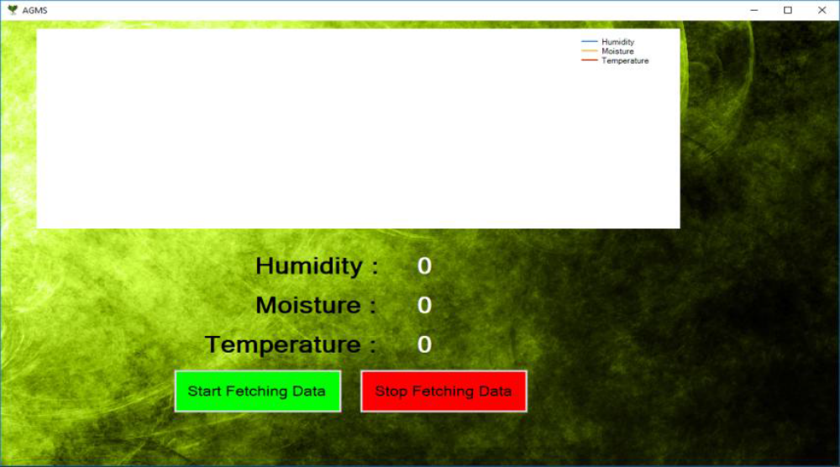
Result Analysis with the specific readings using Application Server

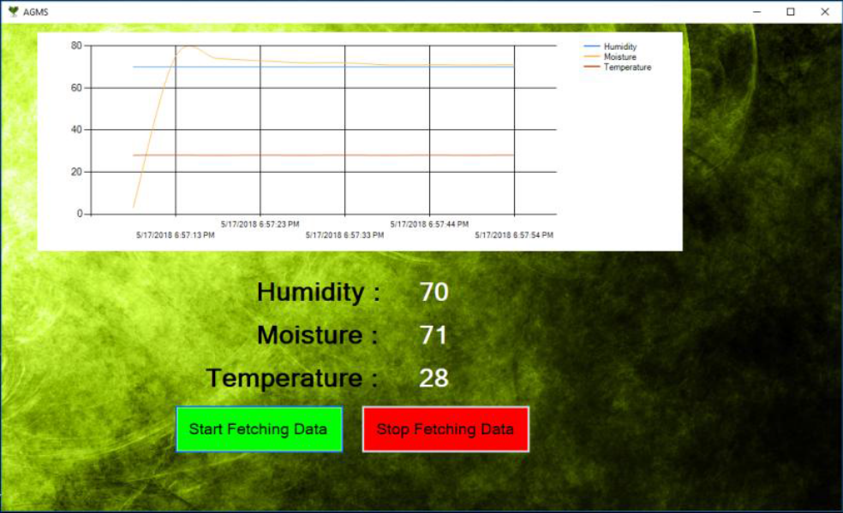

FUTURE SCOPE
Future work would be focused more on increasing sensors on this stick to fetch more data especially with regard to Pest Control and by also integrating GPS module in this IoT Stick to enhance this Agriculture IoT Technology to full-fledged Agriculture Precision ready product.
• Implementation of Foggers
• Implementation of sliders.
• Implementation of roof sheets.
• Implementation of controllable water motor.
• Detection of gases/minerals above/under the ground & detection of insects.

CONCLUSION:
According to FAO forecasts, the world would need to produce 70% more food in 2050 as the human population grows rapidly. As a result, agricultural fields would shrink and scarce natural resources will be depleted. So agricultural yields must be increased urgently to fulfil demand, Internet of Things (IoT) may play a significant role in this process. Farmers and ranchers may now practice smart farming with the help of IoT. Farmers may spend less time in the field while still increasing crop yields thanks to smart farming. In the agriculture industry, the IoT-based ecosystem offers a variety of uses. To summarize, IoT applications enable farmers to collect valuable data that can be used to improve efficiency. Landholders and small farmers must realize the benefits of IoT-based smart farming and should effectively implement IoT solutions.
This concept can be implemented in a real greenhouse for growing good agricultural produce which can be of export quality. The system will take care of automatic irrigation control and various parameters of the greenhouse can be monitored like Temperature, Humidity and Soil Moisture. The Android Application form the user interface and to record the parameter details we use an application server module. This recorded data can be used for analysis and help in taking decisions.

References:
1. Elijah, O., Rahman, T.A., Orikumhi, I., Leow, C.Y., Hindia, M.N. (2018): An overview of internetof things (IoT) and data analytics in agriculture: benefits and challenges. IEEE Internet Things J. 1–1
2. Sales, N., Remedios, O., Arsenio, A. (2015): Wireless sensor and actuator system for smart irrigation on the cloud. In: IEEE World Forum on Internet of Things, WF-IoT Proceedings, pp. 693–698. IEEE
3. Jin, J., Ma, Y., Zhang, Y., Huang, Q. (2018): Design and implementation of an agricultural IoT based on LoRa. MATEC Web Conf. 189, 04011

4. “Greenhouse Monitoring and Automation System Using Microcontroller”, International Journal of Engineering Trends and Technology (IJETT) – Volume45 Number 5– March 2017.
V. Dan, Liu, et al. "Intelligent Agriculture Greenhouse Environment Monitoring System Based on IOT Technology." Intelligent Transportation, Big Data and Smart City (ICITBS), 2015 International Conference on. IEEE, 2015.

5. Aqeel-ur-Rehman, A., Abbasi, A. Z., Islam, N., &Shaikh, Z. A. (2014): A review of wireless sensors and networks' applications in agriculture. Computer Standards & Interfaces, 36(2), 263–270. https://doi. org/10.1016/j.csi.2011.03.004
6. Zhang, S., Wang, Y., Zhu, Z., Li, Z., Du, Y., & Mao, E. (2018):Tractor path tracking control based on binocular vision. Information P

7. Nikesh Gondchawar and Prof. Dr. R.S.Kawitkar, “IoT Based Smart Agriculture,” International Journal of Advanced Research in Computer and Communication Engineering, Vol. 5, Issue 6, June 2016.
8. Ranjitha K, “Smart Farm Management using Raspberry-Pi and Internet Of Things (IoT),” International Journal of Innovative Research in Computer and Communication Engineering, Vol. 6, Issue 6, June 2018.

9.Chauhan, N., Krishnakanth, M., Kumar, G. P., Jotwani, P., Tandon, U., Gosh, A.,&Santhi, V. (2019, March):Crop Shop–An application to maximize profit for farmers. In 2019 International Conference on Vision Towards Emerging Trends in Communication and Networking (ViTECoN), 1-7. IEEE.
10. Stewart, J., Stewart, R., Kennedy, S.(2017): Internet of things — propagation modelling for precision agriculture applications. In: 2017 Wireless Telecommunications Symposium (WTS), pp. 1–8. IEEE
11. Boursianis, A. D., Papadopoulou, M. S., Diamantoulakis, P., LiopaTsakalidi, A., Barouchas, P., Salahas, G., et al. (2020): Internet of Things (IoT) and agricultural unmanned aerial vehicles (UAVs) insmart farming: a comprehensive review. Internet of Things, 100187.https://doi.org/10.1016/j.iot.2020.100187
12. Adame, T., Bel, A., Bellalta, B., Barcelo, J., & Oliver, M. (2014).Wi Fi approach for M2M communications IEEE Wireless Communications, 21(6), 144–152. https://doi.org/10.1109/MWC.2014.7000982
13. Zhou, L., Song, L., Xie, C., & Zhang, J. (2012). Applications of Internet of Things in the facility agriculture. In D. Li & Y. Chen (Eds.), Computer and computing Technologies in Agriculture VI (pp.297–303). Heidelberg: Springer Berlin Heidelberg
14. Barcelo-Ordinas, J. M., Chanet, J. P., Hou, K. M., &García-Vidal, J. (2013): A survey of wireless sensor technologies applied to precision agriculture. In Precision agriculture’13, 801-808.Wageningen Academic Publishers, Wageninge

